**Verification and Validation Testing**

**Verification testing:**

Verification testing includes different activities such as business requirements, system requirements, design review, and code walkthrough while developing a product.

It is also known as static testing, where we are ensuring that "**we are developing the right product or not**". And it also checks that the developed application fulfilling all the requirements given by the client.

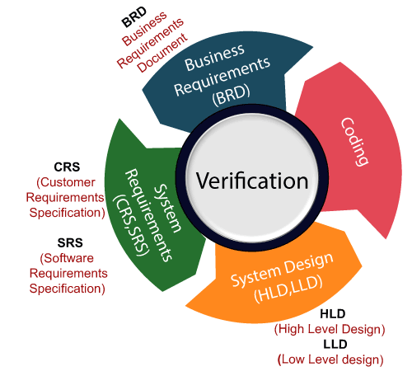

**Validation testing**

Validation testing is testing where tester performed functional and non-functional testing. Here functional testing includes Unit Testing (UT), Integration Testing (IT) and System Testing (ST), and non-functional testing includes User acceptance testing (UAT).

Validation testing is also known as dynamic testing, where we are ensuring that **"we have developed the product right."** And it also checks that the software meets the business needs of the client.

